Now we see how to find the 1 nearest negibour ie 1-NN.

We have to find 1 nearest neighbor for q, whose x and y dimensions are known, therefore we traverse through k-d tree according to this dimensions until we reach leaf.

Let’s say by traversing we reach to the rectangle box of ‘c’ that mean qis nearest to c.

But as we can see that gemotrically e is more closer.

So we draw the circle considering the radius as distance between q and c called it d, store the distance between q and c.

Now we’ll look in all the boxes whose axis are intersected. Since in our example y1 axis is intersected, therefore we back track to y1 in kd-tree, and again repeat the same process of traversing looking at x and y dimensions until we reach leaf.

And by traversing we reach to e. And now we calculate the distance between q and e, called it d’.

Since d’ < d, so now our nearest distance is d’ and we remove d from list.

Now we again draw the circle, considering the radius as d’, and repeat the whole process, until circle do not intersect any axis.

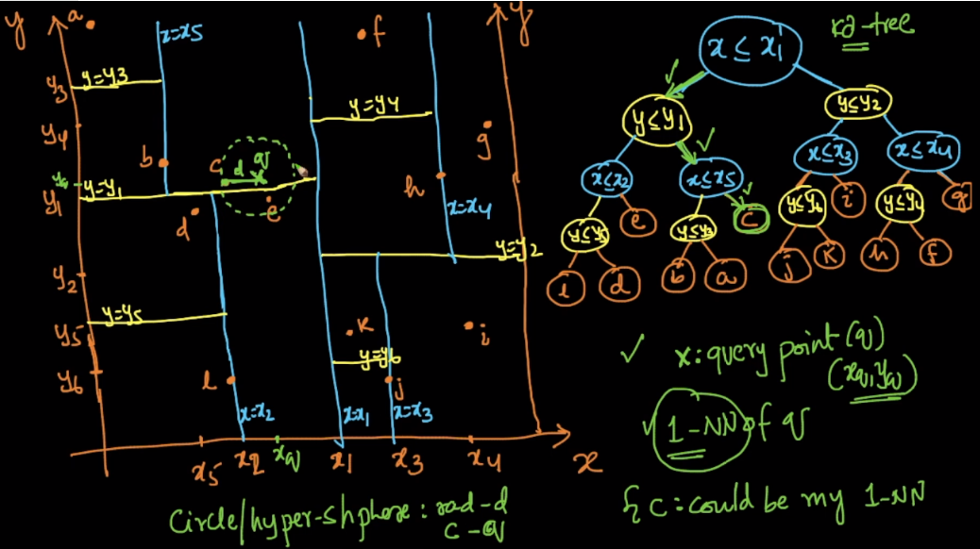

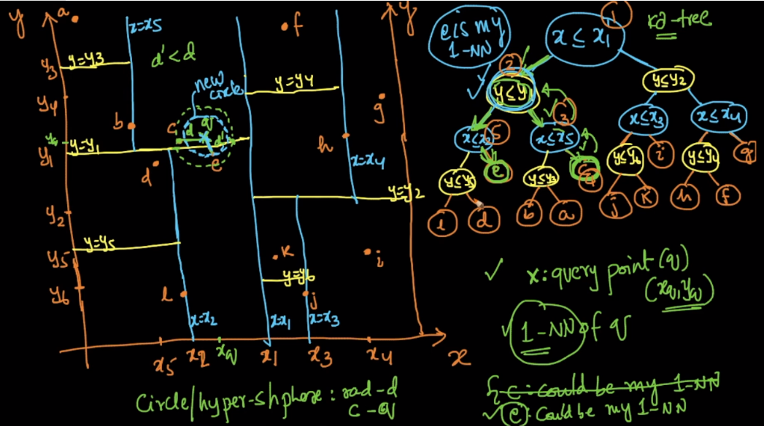

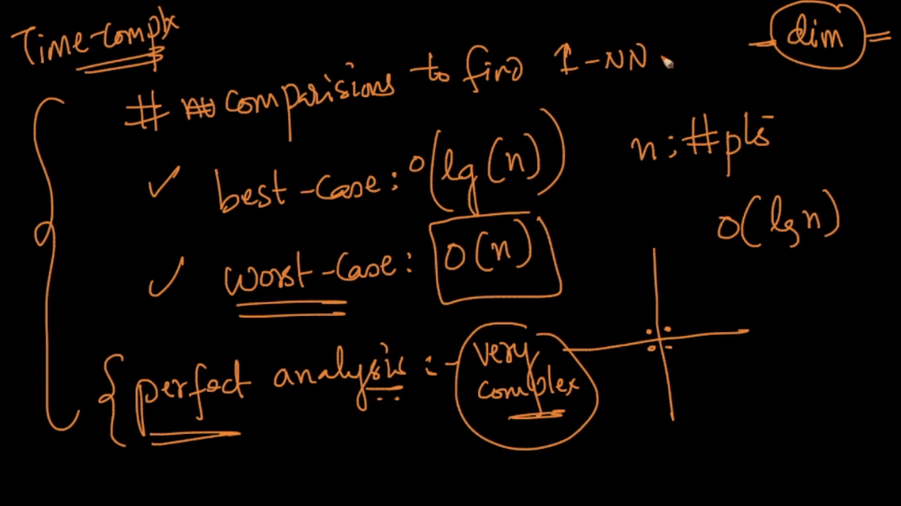

**How do we do it for k > 1.**

Repeat the whole process for each nearest neighbor ignoring all the point finds earlier.

Example suppose k = 3.

Find 1st nearest neighbor using whole process.

Find 2nd nearest neighbor by ignoring the 1st nearest neighbor thinking as if it was not here.

Find 3rd nearest neighbor by ignoring 1st and 2nd NN.

